Crop management Breeding Trials
Just make a simple report:
Enter: researcher name: and Month it will give all the trials done by that researcher on that particular month:

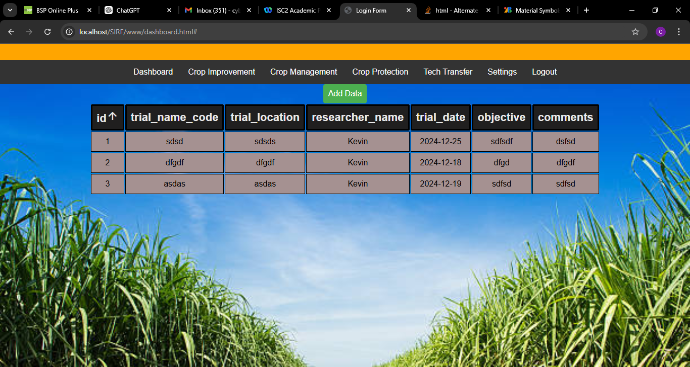

Crop management – Soil testing
Selection date and field location : should give all other fields in the report

